In this lesson we will talk about webgl and Teacher have been very interested in graphic programming for a long time and he also think that js is possibly the best programming language to ever grace mankind so webgl is the perfect combination of the two (graphics and js) Its way for you to write front end client side application that use the full power of OpenGL

0:22

Or at least OpenGL as Teacher think that it’s the 2.0 standard that the webgl uses So we are going to do bunch of lesson pretty much until we get bored of these which should take long more time

In this first lesson we all are going to set up webgl so you see Teacher we have little cavas In Teachers window as shown below

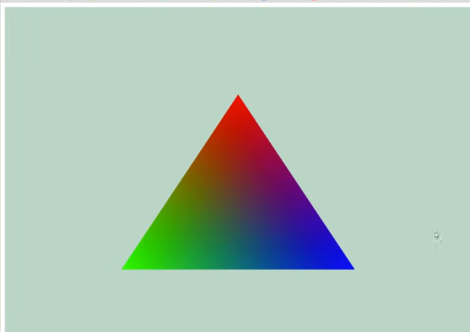

So we have drawn a simple triangle so this is getting all the boring overhead stuff out of the way we are going to talk a little bit about the **graphics pipeline** and how that works So if you want to fully understand how that works Teacher recommend different write up on that(maybe telling different tutorial )

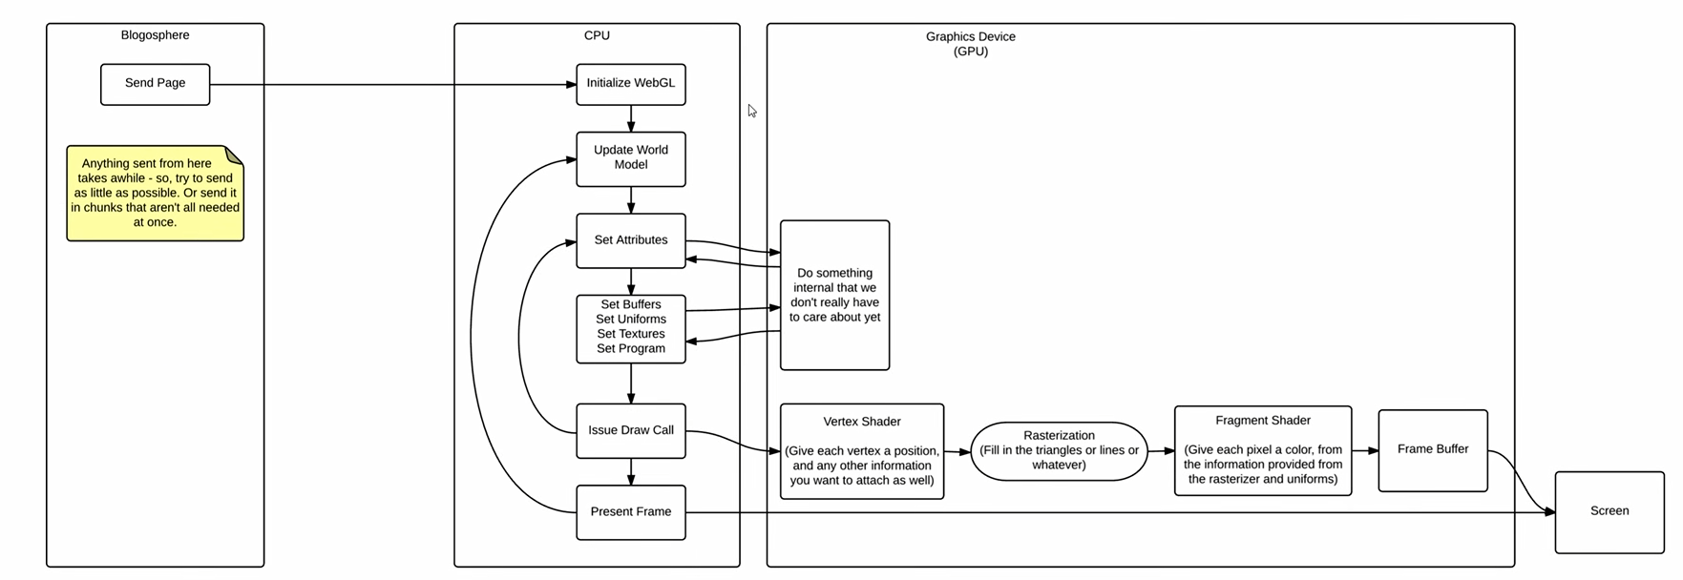

Considering this is there is quite a lot that goes on so above is a simple mockup of how graphic application works and when teacher say Graphic application think video games. Especially Teacher want us to think about you have ever played on the or playstation 1, one of those old video games where everything looked very boxy

1:15